1 Hour spent on this assignment
My program seemed pretty unbreakable but in the off-chance something goes wrong the program will just print “A unknown error occurred” and exit.
I also prevented the use of the html flags < and > to prevent the website from interpreting it as code.
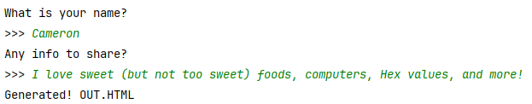
Output:
Python:

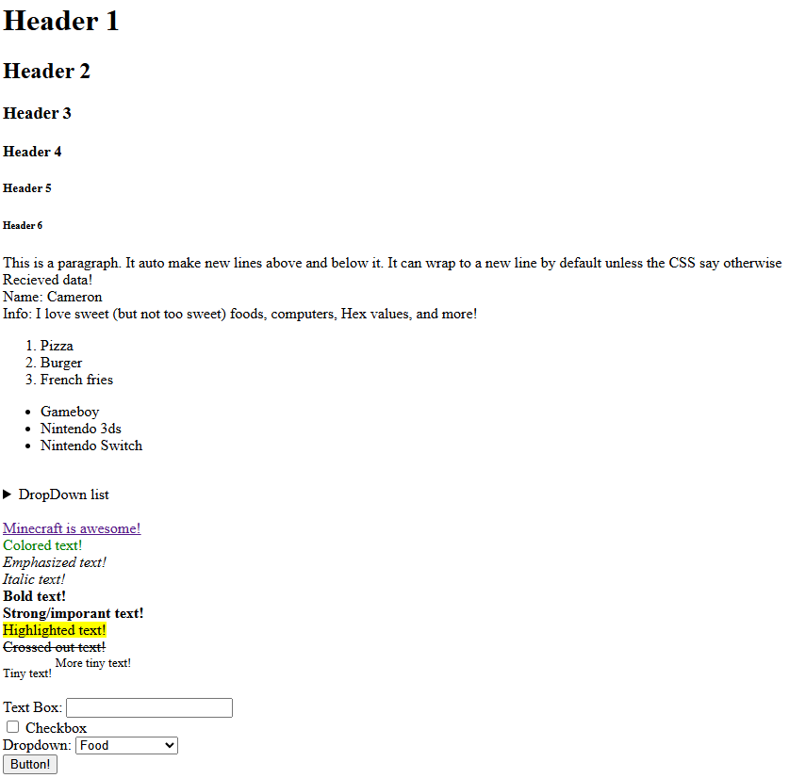
HTML:

